Demin water pumps
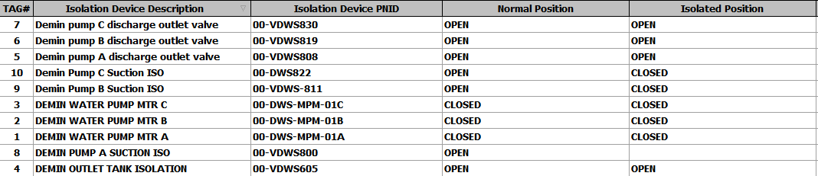
Service water
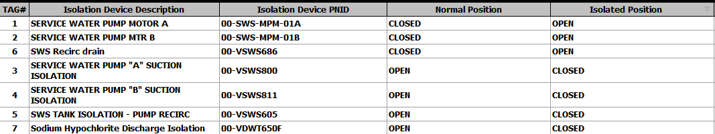
Instrument Air compressor Alpha
Instrument Air compressor Bravo
Air Dryer Alpha
Air Dryer Bravo
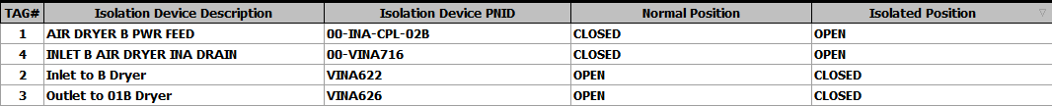
Aux Boiler inspection
